**ESS 132 Week 6/7 Tasks**

1. Explain, with reference to the mathematical equation for infiltration, why the infiltration rate at the end of the storm is less than at the beginning.

Infiltration rate depends on the gradient in pressure head with respect to the gradient in the elevation head. As time passes, the gradient in the pressure head decreases as both the surface of the soil and deeper below the soil becomes equally saturated and so their tension on water decreases. This decrease in tension and the gradient in the pressure head results in decreasing infiltration rates.

1. Green-Ampt method

Use the information below to construct the infiltration rate over the course of the storm using the Green-Ampt model of infiltration. Then fill in the appropriate values for A-F based on your spreadsheet values.

Duration of storm = 3 hours Initial water content = 0.15 cm3/cm3

Rainfall rate = 0.6 cm/hr Saturated water content = 0.5 cm3/cm3

Ksat = 0.1 cm/hr ψ = 15 cm

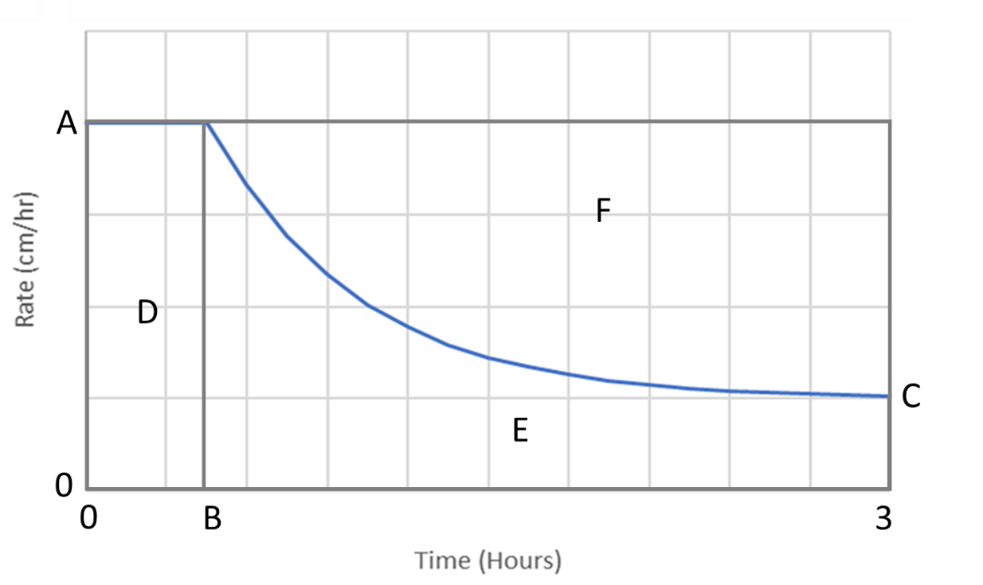

A = 0.6 cm/hr

B = 1.75 hr

C = 0.416 cm/hr

D = 1.05 cm

E = 1.66 cm

F = 0.139 cm